1. Write a python program that takes user’s name (full name) and age as input and prints it in following format

Sample Output: What’s your name?

Fazlur rahim

What’s your age?

62

Output: Hello, Rahim! You are 62 years old.

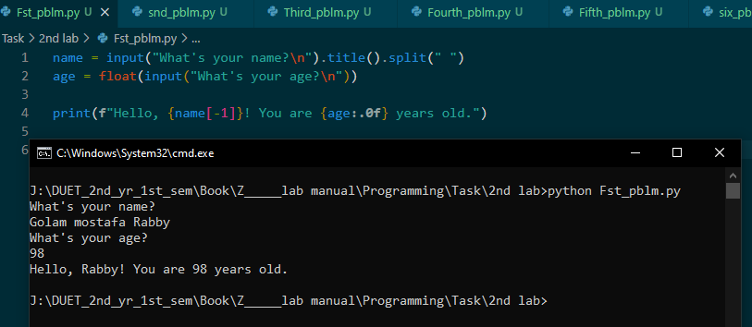

2. Write a Python program that calculates the area of a circle based on the radius entered by the user. Define your own function for area calculation. And print the area up to 3 decimal points.

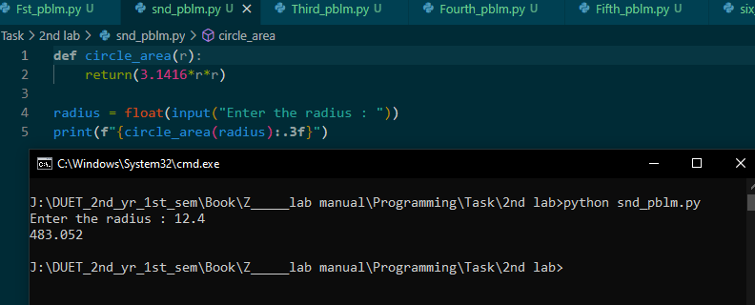

3. Write a Python program that take user’s score and determine his/her grade.

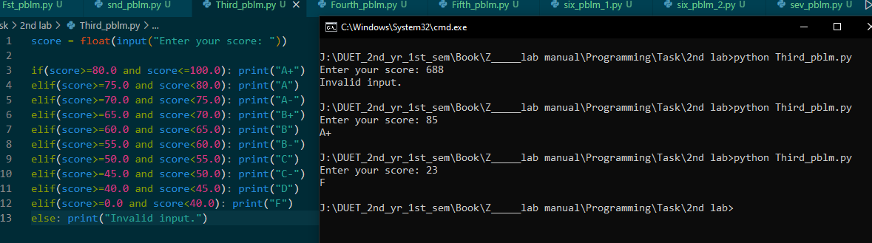

4. Write a Python program that determines whether a given number (accepted from the user) is even or odd, and prints an appropriate message to the user. Define a function ‘is_even’ to check whether the number is even or odd.

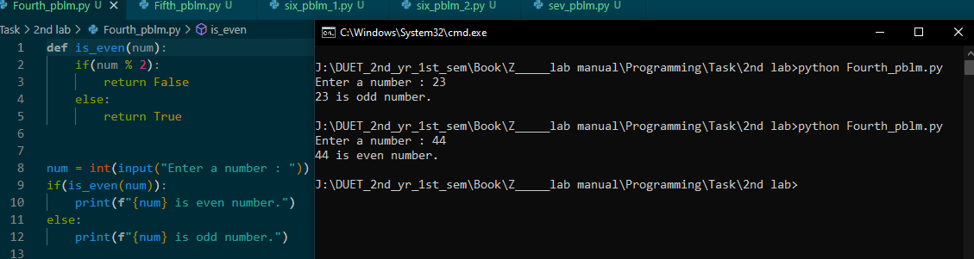

5. Write a Python program to display the first and last colors from the following list.

color_list = ["Red","Green","White" ,"Black"]

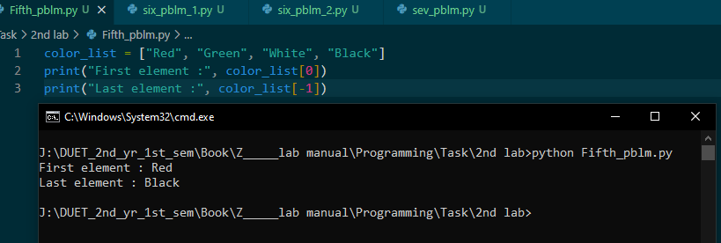

6. Write a python program to calculate the summations of the following series for given values of x and n:

i) 4 – 4/3 + 4/5 – 4/7+…………….. nth term .

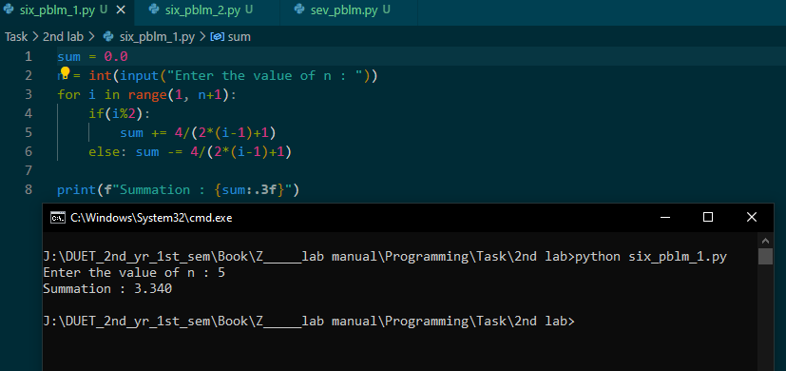

ii) 1 + x/1! + x2 /2! + x3 /3! +…………….. + xn /n!

Also compare the result with (i) the constant π , (ii) ex .

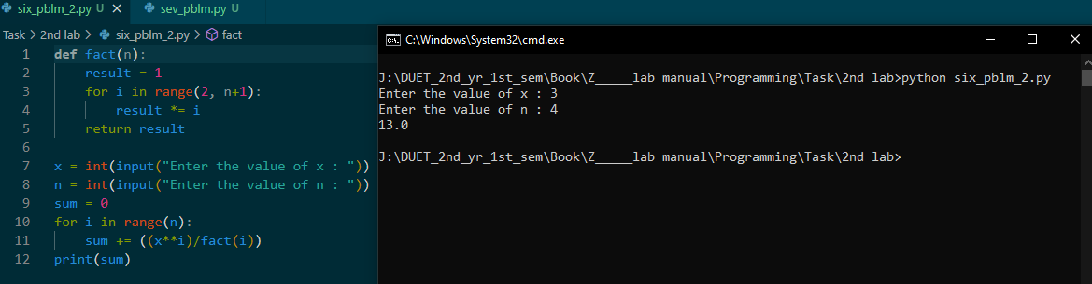

7. Write a Python program which accepts a sequence of comma separated 4-digit binary numbers as its input and print the numbers that are divisible by 4 in a comma separated sequence.

Input : 0110,0011,1010,1001,1100

Expected Output : 1100

